**This is a document about the movement of characters, bosses, and enemies in the game**

**Juan**

Juan is a guy who slides, dashes, and punch, and kick his way to victory. With that we want to go off of what we should do.

Lets take games like x-men,the simpsons, tmnt, castle crashes, scott pilgrim. Only this game you will stay on a flat platform and you only jump and move across. Thinking this way we can say that we have to use the directions to do different things. Think of it as like a sort of fighter style game.

Jump crouch

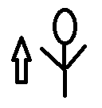 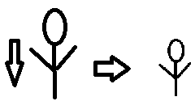

Dashing crouching moves

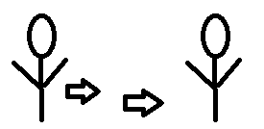 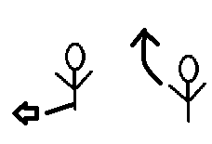

Jumping moves Dashing Moves

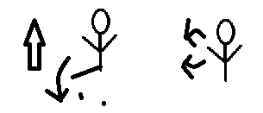 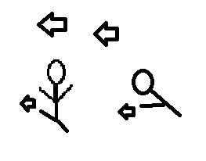

Jumping

When you are jumping we want to say that you are two juan stack upon each other up so you would be the third juan (one). When you jump you have three moves, to kick down which makes u kick downwards like an axe kick and knock enemies down, or you punch or kick and you either continue to hit enemies that are still in the air and you and them suspend til an amount of time, or just away to hit flying enemies.

Crouching

When crouching you are half the size of juan. So juan (one) half. You can low kick sort of like street fighter or you can punch forward. However if you duck then up and punch you do an uppercut straight into a jumping stance.

Dashing

When dashing we want to say you dash about juan(one) second forward. When you dash you use it to try to dodge or use it to get closer to enemies. The moves are dashing and punching causing a tackle. Dashing and kicking is a flying kick. While dashing while moving directional down makes you slide kick.